**Problem Statement:** [**https://leetcode.com/problems/richest-customer-wealth/description/**](https://leetcode.com/problems/richest-customer-wealth/description/)

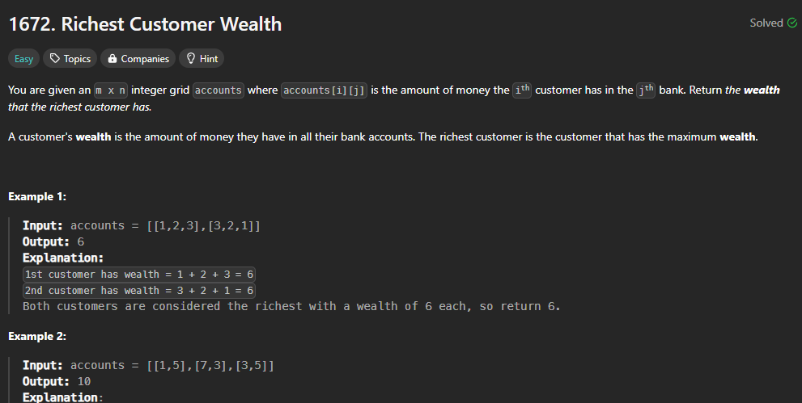

**Brute force Method:**

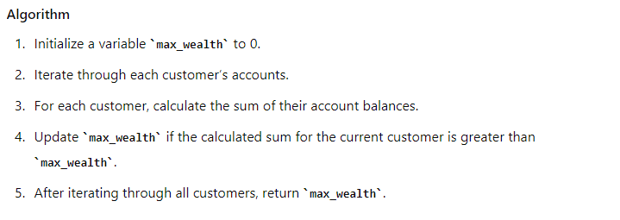

**Code:**

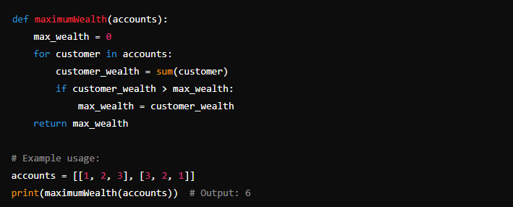

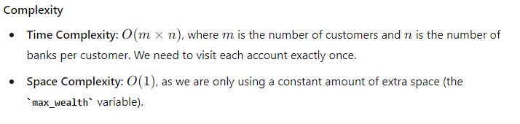

**Sol2: Using List comprehensions**

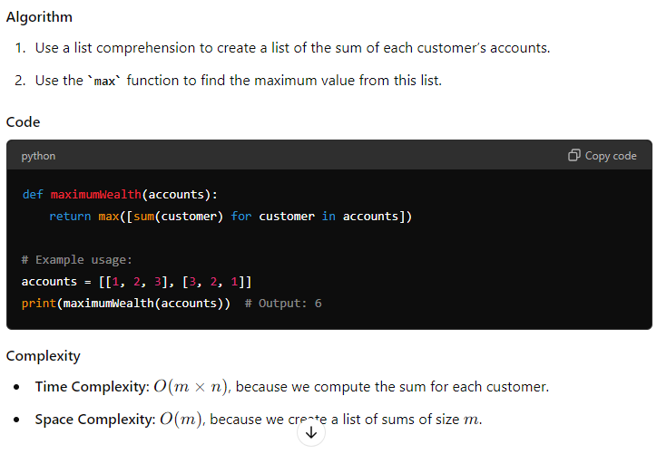

**Sol3: Using Numpy Arrays**

